LOAN SWAP MANAGEMENT SYSTEM (LSMS)
Software Development Plan & Software Quality Assurance Plan
Prepared for: Meridian Commercial Bank (MCB)
Group Assignment - Software Engineering & Quality Assurance
Group Members: [Insert 8 names & registration numbers]
Course / Lecturer: [Insert course & lecturer name]
Date: [Insert submission date]

Question 1: Organization & Project Overview

1.1 Description of the Selected Organization
Meridian Commercial Bank (MCB) is a hypothetical, mid-sized commercial bank operating a network of 40 branches and a growing digital banking channel across East Africa. MCB offers retail, SME and corporate banking services, with a loan book that spans mortgages, auto loans, personal loans and SME working-capital facilities. The bank positions itself as a customer-centric, digitally progressive institution and is regulated by the national central bank.

1.2 Business Activities
MCB's core business activities include:
- Deposit mobilization (current, savings and fixed-deposit accounts).
- Loan origination, underwriting and disbursement across retail, SME and corporate segments.
- Loan servicing, including repayment collection, restructuring and loan product changes.
- Digital banking services (mobile app, internet banking, USSD).
- Treasury, trade finance and card services.

1.3 Business Problem / Opportunity
MCB's loan customers frequently need to change the terms of an existing loan - for example, swapping from a fixed interest rate to a variable rate (or vice versa) when market rates move, changing the loan tenor, or consolidating multiple loans into a single facility with a different repayment structure. Currently, this "loan swap" process is entirely manual: customers visit a branch, relationship managers complete paper forms, credit and risk teams manually recompute amortization schedules in spreadsheets, and approvals are routed by email. The process takes 10-15 working days, is error-prone, offers no visibility to management, and has led to customer complaints, revenue leakage from miscalculated schedules, and audit findings. This represents both an operational problem and an opportunity to differentiate MCB through faster, digital, self-service loan servicing.

1.4 Proposed Software Solution
The proposed solution is the Loan Swap Management System (LSMS), a web-based platform comprising: (a) a customer self-service portal for initiating and tracking loan swap requests; (b) a staff back-office workflow module for eligibility checks, credit review and multi-level approval; (c) an automated amortization and rate-recalculation engine; and (d) real-time integration with MCB's Core Banking System (CBS), the national Credit Reference Bureau, and the document management system for e-signatures. The system will support three swap types: rate-type swaps (fixed ↔ variable), tenor swaps, and loan consolidation/product swaps.

1.5 Project Objectives
- Deliver a fully functional, tested and regulator-compliant LSMS within 12 months and within the approved budget.
- Reduce average loan swap turnaround time from 10-15 days to under 2 business days.
- Automate at least 90% of amortization recalculations, eliminating manual spreadsheet errors.
- Achieve seamless, real-time integration with the Core Banking System and Credit Reference Bureau.
- Ensure full compliance with central bank consumer-lending and data-protection regulations.
- Achieve a post-implementation customer satisfaction score of at least 85%.

1.6 Expected Benefits
- Faster, more transparent loan servicing that improves customer retention and satisfaction.
- Reduced operational cost through automation of manual, paper-based processes.
- Improved regulatory compliance and audit-readiness through system-enforced controls and audit trails.
- Better management visibility through real-time dashboards and reporting on loan swap volumes and revenue impact.
- Reduced financial and reputational risk from calculation errors and processing delays.

Question 2: Software Development Plan (SDP)

2.1 Project Objectives
The SDP governs the delivery of the LSMS. Its objectives are to define how the project will be planned, executed, monitored and closed so that the system described in Question 1 is delivered on time, within budget, to the agreed scope, and in compliance with MCB's IT governance and regulatory obligations.

2.2 Project Scope
In scope: Customer self-service portal; staff workflow and approval module; rate-swap, tenor-swap and loan-consolidation engines; CBS and Credit Bureau integration; e-signature and document management integration; management reporting/dashboards; user training and post-go-live hypercare support.
Out of scope: New loan origination functionality, a dedicated mobile application (planned as a Phase 2 initiative), and changes to MCB's general ledger or core accounting rules beyond what is required for loan-swap postings.

2.3 Development Methodology
The project will use a hybrid Agile-Waterfall approach. Requirements, architecture and regulatory sign-off follow a structured, gated (waterfall-style) approach because banking projects require formal compliance approval before implementation begins. Within the implementation and testing phases, the team will use Scrum, with two-week sprints, sprint reviews and retrospectives, to allow iterative development, early feedback from MCB business stakeholders, and flexibility to refine detailed requirements. This hybrid model balances regulatory rigor with delivery agility.

2.4 Project Organization
The project is delivered by a multidisciplinary team led by a Project Manager and governed by a Client Steering Committee. Roles include a Business Analyst, Technical Lead/Solution Architect, Backend and Frontend Developers, a Database Administrator, a UI/UX Designer, a QA Lead with Software Testers, and a Change & Communications Officer.
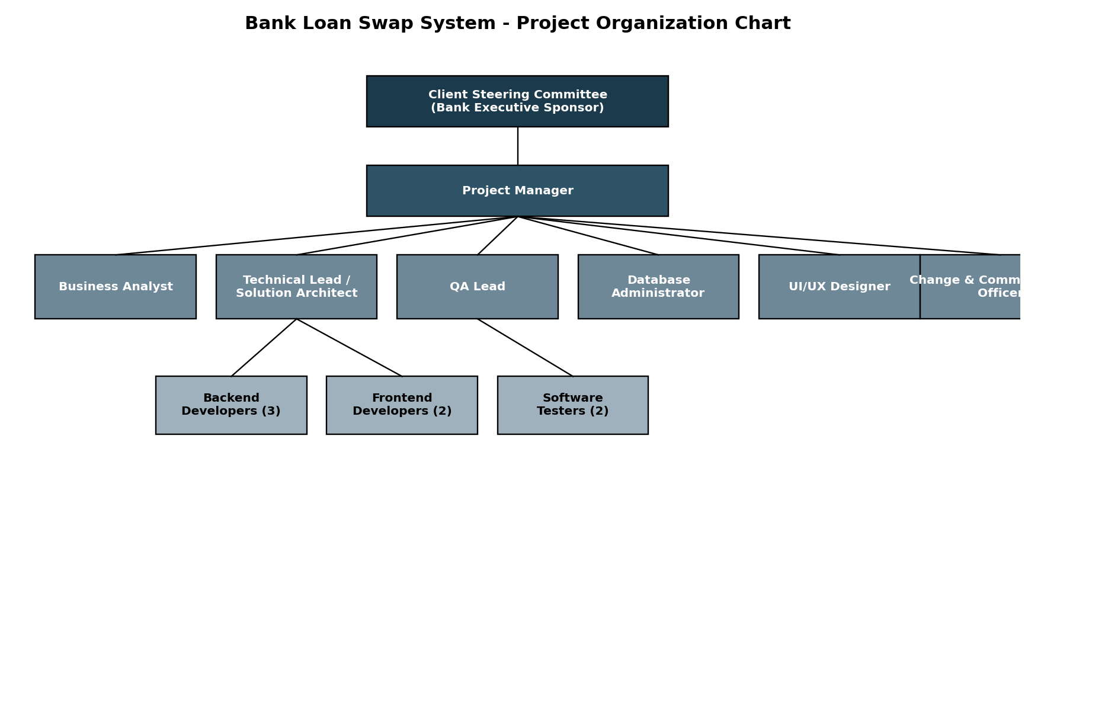
Figure 1: Project Organization Chart

2.5 Work Breakdown Structure (WBS)
WBS Code | Deliverable / Work Package | Description
1.0 | Project Management | Charter, planning, monitoring & control, closure
1.1 | Project Charter & Kick-off | Define objectives, scope, governance
1.2 | SDP & SQAP Development | Prepare and approve planning documents
2.0 | Requirements Analysis | Elicit and document business & system requirements
2.1 | Stakeholder Workshops | Business, credit, risk & compliance requirements
2.2 | Requirements Specification | SRS document and sign-off
3.0 | System Design | Architecture, database, UI/UX, integration design
3.1 | Solution Architecture | High-level architecture and technology stack
3.2 | Database Design | Data model, ERD, migration design
3.3 | UI/UX Design | Wireframes, prototypes, usability testing
4.0 | Implementation | Build core modules and integrations
4.1 | Customer Portal | Self-service swap request module
4.2 | Staff Workflow Module | Approval and case management
4.3 | Rate/Amortization Engine | Swap calculation logic
4.4 | CBS & Credit Bureau Integration | APIs and data exchange
5.0 | Testing | Unit, integration, system, UAT, security, performance
6.0 | Deployment | Data migration, cutover, go-live
7.0 | Maintenance & Closure | Hypercare, handover, lessons learned

2.6 Project Schedule

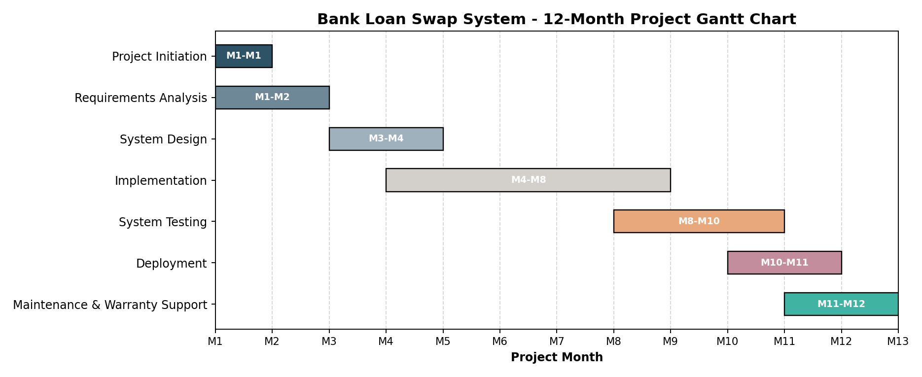

2.7 Resource Allocation
Role | Number | Key Phases Involved | Allocation
Project Manager | 1 | All phases | 100%
Business Analyst | 1 | Initiation, Requirements, UAT | 100% (Months 1-3, 8-10)
Technical Lead / Architect | 1 | Design, Implementation, Deployment | 100%
Backend Developers | 3 | Implementation, Testing | 100% (Months 3-9)
Frontend Developers | 2 | Implementation, Testing | 100% (Months 3-9)
Database Administrator | 1 | Design, Implementation, Deployment | 75%
UI/UX Designer | 1 | Design, early Implementation | 100% (Months 2-5)
QA Lead | 1 | All phases | 100%
Software Testers | 2 | Testing, UAT, Deployment | 100% (Months 7-11)
Change & Communications Officer | 1 | Requirements, Deployment, Maintenance | 50%

2.8 Budget Assumptions
Budget Category | Assumption / Basis | % of Budget
Personnel (salaries/contractor fees) | 10-person team over 12 months, blended rates | 55%
Infrastructure & Cloud Hosting | Production, staging & DR environments | 12%
Software Licenses & Tools | IDE, project mgmt, testing & security tools | 8%
Core Banking Integration Middleware | API gateway / middleware licensing and setup | 10%
Training & Change Management | Staff and customer onboarding materials | 5%
Contingency Reserve | Standard 10% contingency on identified risks | 10%
All figures are assumption-based estimates for planning purposes and would be refined during detailed budgeting with MCB Finance.

2.9 Risk Management Plan
Risk management follows a continuous cycle of identification, qualitative assessment (likelihood x impact), response planning, and monitoring, reviewed at each sprint review and steering committee meeting. The Project Manager maintains a risk register and escalates severe risks to the Steering Committee. A dedicated risk-assessment matrix is used to prioritize response effort.

2.10 Communication Plan
Audience | Content | Frequency | Channel
Steering Committee | Progress, risks, budget, decisions needed | Monthly | Steering committee meeting + report
Project Sponsor | Milestone status, escalations | Bi-weekly | Email + status report
Development Team | Sprint planning, backlog, blockers | Daily / bi-weekly | Daily stand-up, sprint ceremonies
Business Users (Branch & Credit staff) | Requirements validation, UAT, training | At key milestones | Workshops, UAT sessions
Compliance & Risk Department | Regulatory checkpoints | At each phase gate | Formal review meeting
Customers (end users) | Change announcements, go-live communication | Pre/post go-live | Email, SMS, in-app notices

Question 3: Software Quality Assurance Plan (SQAP)

3.1 Quality Objectives
- Achieve less than 1% critical/high-severity defect leakage into production.
- Maintain system availability of at least 99.5% post-go-live.
- Achieve 100% compliance with central bank IT and consumer-protection regulations.
- Achieve at least 90% automated test coverage for core calculation logic.
- Achieve a UAT sign-off with zero open critical defects.

3.2 Applicable Standards and Procedures
- ISO/IEC 25010 - Software product quality model (functionality, reliability, usability, security, etc.).
- ISO/IEC/IEEE 29119 - Software testing standard, for test process and documentation.
- ISO 9001 - Quality management system principles applied to project processes.
- OWASP Application Security guidelines - for secure coding and penetration testing.
- Central Bank IT risk management and data protection guidelines applicable to financial software.
- MCB's internal SDLC policy and change-management procedures.

3.3 Review and Inspection Activities
- Requirements walkthroughs with business analysts, credit/compliance and QA sign-off.
- Design reviews for architecture, database schema and integration design.
- Peer code reviews for every pull request, supported by static code analysis.
- Documentation reviews for the SRS, design documents, test plans and user manuals.

3.4 Testing Strategy
Testing is layered across the SDLC and combines manual and automated techniques:
- Unit Testing - developers, automated, target 90% coverage on calculation logic.
- Integration Testing - verifies CBS, Credit Bureau and e-signature integrations.
- System Testing - end-to-end functional testing against the SRS.
- User Acceptance Testing (UAT) - MCB business, credit and compliance users validate real scenarios.
- Regression Testing - automated suite run before every release.
- Security / Penetration Testing - conducted by an independent security team before go-live.
- Performance Testing - load and stress testing to validate response times under peak volumes.
Each level defines entry and exit criteria; for example, System Testing may only begin once Integration Testing exit criteria (no open critical defects) are met.

3.5 Quality Metrics
Metric | Target
Defect density | < 2 defects per 1,000 lines of code at release
Defect removal efficiency | > 90% of defects found before production
Test coverage (automated) | ≥ 90% for calculation/business-logic modules
Mean time to resolve critical defects | < 24 hours
System availability post go-live | ≥ 99.5%
UAT defect closure rate before go-live | 100% of critical/high defects closed

3.6 Defect Management Process
All defects are logged in the project's tracking tool (e.g., Jira) and classified by severity (Critical, High, Medium, Low) and priority. The workflow follows: New → Triage → Assigned → In Progress → Fixed → Retest → Closed (or Reopened). Service-level targets are defined per severity, e.g., critical defects triaged within 4 hours and fixed within 24 hours.

3.7 Quality Audits
- Phase-gate audits before each major SDLC transition (e.g., before moving from Design to Implementation).
- Monthly internal QA process audits by the QA Lead, reporting to the Steering Committee.
- Independent regulatory/compliance audit prior to go-live, covering security and data protection.

3.8 Acceptance Criteria
- All prioritized functional and non-functional requirements in the SRS are implemented and verified.
- No open critical or high-severity defects at the point of go-live decision.
- UAT formally signed off by MCB business, credit and compliance stakeholders.
- Security and performance testing results meet agreed thresholds.
- System documentation, training materials and support runbooks are complete and delivered.

3.9 Continuous Improvement Plan
- Sprint retrospectives after every sprint to capture process improvements.
- Root cause analysis (RCA) conducted for every critical production defect.
- A lessons-learned log maintained throughout the project and reviewed at project closure.
- Quality metrics trends reviewed monthly to identify and act on adverse trends early.

Question 4: SDP vs SQAP Comparison
# | Comparison Point | Software Development Plan (SDP) | Software Quality Assurance Plan (SQAP)
1 | Primary Purpose | Plans how the software will be built, managed and delivered | Plans how quality will be assured and verified throughout delivery
2 | Primary Focus | Scope, schedule, cost, resources, delivery process | Standards, reviews, testing, defects, quality metrics
3 | Primary Owner | Project Manager | QA Lead / Quality Assurance Team
4 | Key Contents | WBS, schedule, budget, org chart, risk plan | Test strategy, review process, metrics, defect process
5 | When Developed | At project initiation, before development starts | In parallel with the SDP, before development starts
6 | Scope of Application | Whole project lifecycle and management activities | All artifacts and processes that affect product quality
7 | Success Measured By | On-time, on-budget, on-scope delivery | Defect rates, compliance, test coverage, customer satisfaction
8 | Typical Tools | MS Project / Gantt tools, budgeting tools | Test management tools, defect trackers, static analyzers
9 | Update Frequency | Updated at major milestones or scope changes | Updated as standards, risks or quality findings evolve
10 | Relationship to Stakeholders | Aligns sponsors, PM and delivery team on delivery commitments | Aligns QA, developers and compliance on quality expectations

Question 5: Project Risk Assessment
Five key risks were identified for the LSMS project. The risk-assessment matrix below plots each risk by likelihood and impact, followed by the detailed risk register.
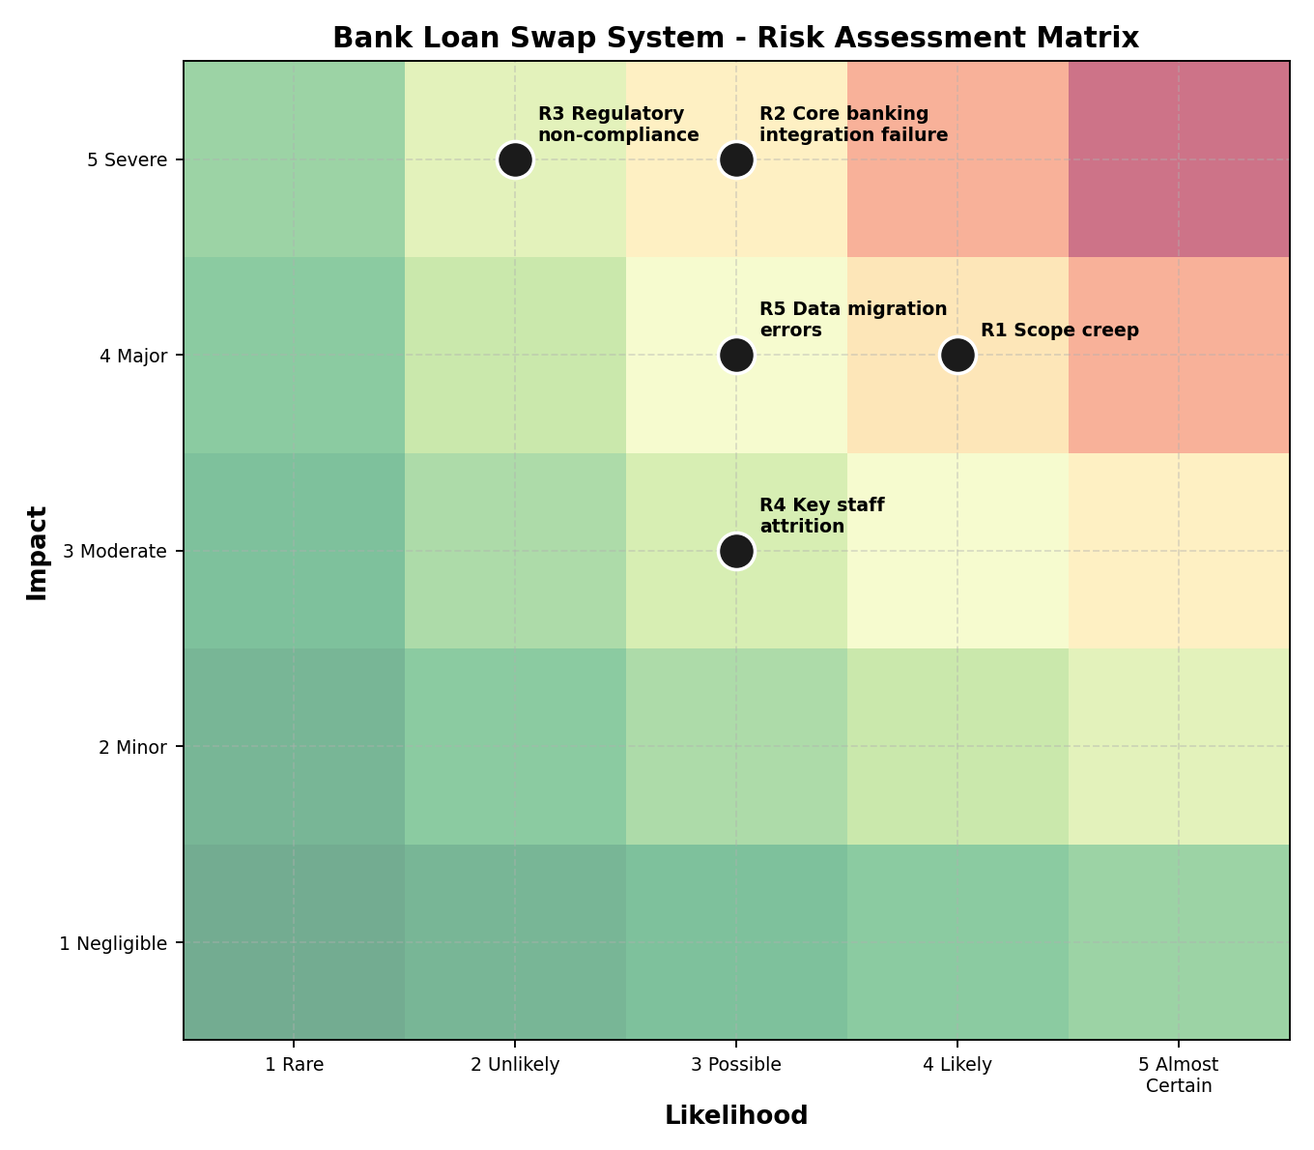
Figure 2: Risk Assessment Matrix (Likelihood x Impact)
Risk | Description | Possible Impact | Likelihood / Risk Level | Mitigation Strategy
R1 - Scope Creep | Business stakeholders request additional swap types or features mid-project | Schedule delays and budget overrun | Likely / High | Formal change-control process; freeze core scope after sign-off; manage additions via a Phase 2 backlog
R2 - Core Banking Integration Failure | CBS APIs are incomplete, undocumented or fail under load | Delayed go-live; incorrect loan balances | Possible / Very High (Critical) | Early integration spike/proof-of-concept; dedicated integration testing phase; vendor SLA with CBS provider
R3 - Regulatory Non-Compliance | System fails to meet central bank lending or data-protection rules | Regulatory penalties; forced project halt | Unlikely / Very High (Critical) | Involve Compliance from requirements stage; independent compliance audit before go-live
R4 - Key Staff Attrition | Technical Lead or senior developer leaves mid-project | Loss of knowledge; schedule delay | Possible / Moderate | Knowledge documentation, pair programming, retention incentives, backup resource identified
R5 - Data Migration Errors | Historical loan data migrated incorrectly during cutover | Incorrect customer balances; financial loss | Possible / High | Data-migration dry runs, reconciliation scripts, parallel run before full cutover

Question 6: 12-Month Project Schedule
The Gantt chart below shows the major phases of the LSMS project across its 12-month duration. Phases overlap where appropriate (e.g., Testing begins before Implementation fully ends, to allow early modules to be tested).

Figure 3: 12-Month Project Gantt Chart
Phase | Duration | Key Outputs
Project Initiation | Month 1 | Project charter, SDP & SQAP approved
Requirements Analysis | Months 1-2 | Signed-off Software Requirements Specification
System Design | Months 3-4 | Architecture, database design, UI/UX prototypes
Implementation | Months 4-8 | Coded and unit-tested modules
System Testing | Months 8-10 | Integration, system, security & UAT complete
Deployment | Months 10-11 | Data migration, cutover, go-live
Maintenance & Warranty Support | Months 11-12 | Hypercare support, handover to operations

Question 7: SDP and SQAP Working Together
The SDP and the SQAP are developed in parallel and operate as two coordinated tracks throughout the SDLC. The SDP defines what will be built and when, sequencing the project through Initiation, Requirements, Design, Implementation, Testing, Deployment and Maintenance. At every one of these phases, the SQAP defines a corresponding quality activity - a review, inspection, test or audit - that verifies the SDP's output before the project is allowed to progress to the next phase. This creates a series of phase gates: for instance, the Requirements phase from the SDP is only considered complete once the SQAP's requirements-inspection and sign-off activity confirms the specification is correct, complete and testable.
The two plans are also linked by feedback: defects, audit findings and quality metrics gathered under the SQAP feed back into the SDP's risk register and schedule (for example, a high defect rate during Implementation may trigger a schedule or resource adjustment under the SDP). Similarly, scope or schedule changes approved under the SDP's change-control process automatically trigger updated SQAP review and test activities. Together, the SDP provides the delivery backbone and the SQAP provides the quality assurance that the delivery actually meets MCB's functional, regulatory and reliability requirements.
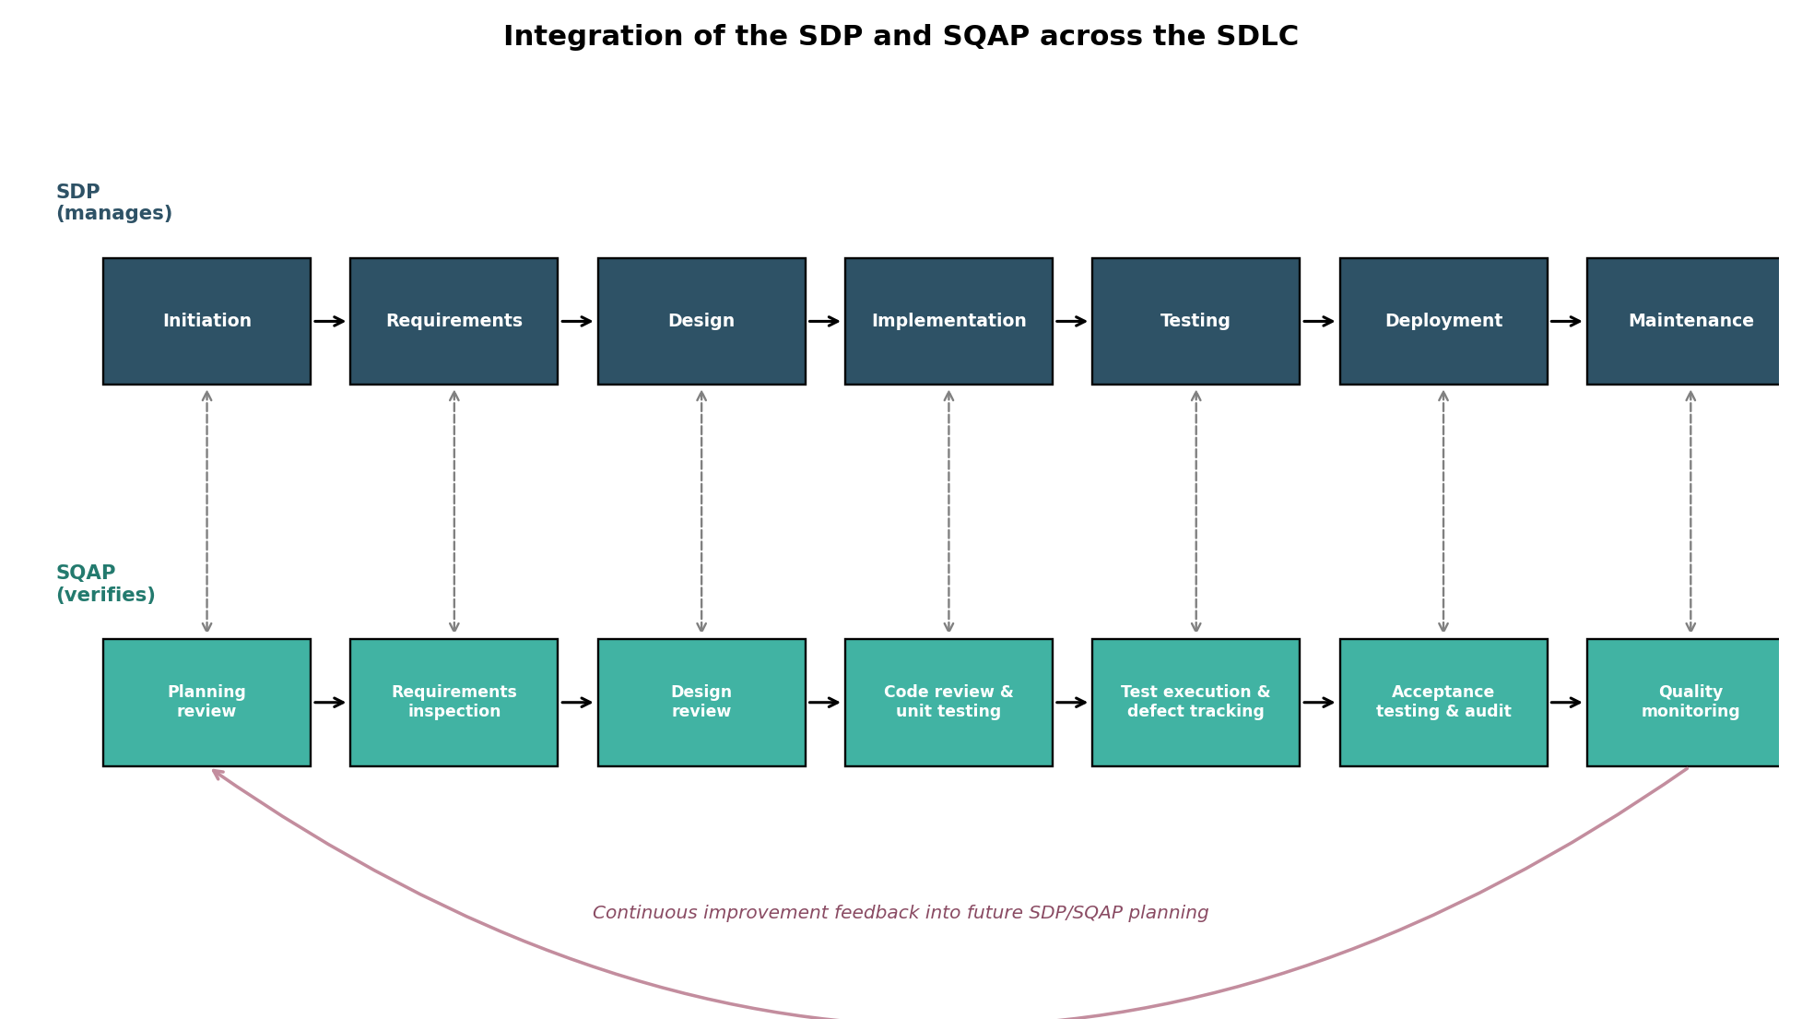
Figure 4: Integration of the SDP and SQAP across the SDLC

Question 8: Scaling Down to a 2-Month Internal Project

8.1 SDP Components That Would Be Simplified
- Project Organization - a smaller, single-team structure would replace the multi-layer steering committee and formal governance structure.
- WBS and Schedule - condensed into fewer, coarser-grained work packages rather than a detailed 7-phase breakdown.
- Budget Assumptions - simplified to an internal cost/effort estimate, without formal external procurement or vendor contracting.
- Communication Plan - reduced to a single internal working group with lightweight, frequent updates rather than formal monthly steering committee reporting.
- Risk Management Plan - a shorter risk list focused only on the highest-priority internal risks, reviewed informally rather than in a dedicated process.

8.2 SQAP Activities That Would Remain Essential
- Security testing - the system still touches customer loan and financial data, so this cannot be skipped regardless of project size.
- Regression and integration testing against the Core Banking System - errors here still risk real financial loss.
- Peer code review and defect management - to maintain a minimum quality bar under time pressure.
- Acceptance criteria and UAT sign-off - to confirm the reduced-scope solution still meets its (narrower) business need.

8.3 Why Planning and Documentation Should Still Be Maintained
Even at a reduced scale, planning and documentation remain important because the project still involves changes to a regulated, financial system: mistakes have real monetary and compliance consequences regardless of project size. Documentation preserves institutional knowledge if the (smaller) team changes, supports faster onboarding, and provides the audit trail regulators and internal audit expect for any change to loan-related systems. Lightweight planning also protects a short, 2-month project from scope creep and rushed, undocumented decisions, which are actually more likely - not less - when time pressure is high and no clear plan constrains the work.

Question 9: Consequences of Skipping the SDP and SQAP
If MCB began developing the LSMS without an SDP and SQAP, the project would face significant risk of failure across schedule, cost, quality and compliance dimensions.

9.1 Schedule and Cost Consequences
Without a WBS, schedule and resource plan, the team would lack a shared understanding of scope and sequencing, leading to unmanaged scope creep, missed dependencies (e.g., starting UI development before the core banking API contract is agreed) and unpredictable delays. Rework caused by discovering these gaps late is typically far more expensive than planning for them up front.

9.2 Quality and Technical Consequences
Without an SQAP, there would be no defined testing strategy or defect process. A realistic example for this project: without a mandated integration and regression test cycle, an error in the amortization recalculation engine could go undetected until production, causing customers to be charged incorrect loan balances - a direct financial loss and a serious customer-trust issue. Without defined code review and quality metrics, defect rates typically rise, and defects found late in the SDLC are significantly more costly to fix than those caught during design or implementation.

9.3 Compliance and Reputational Consequences
Loan products are heavily regulated. Without SQAP-driven compliance reviews and audits, the LSMS could go live without meeting central bank consumer-protection or data-protection requirements, exposing MCB to regulatory penalties, forced remediation, or suspension of the new service. A publicized data or calculation error affecting customer loans would also damage MCB's reputation and could accelerate customer attrition rather than improving retention as the project intended.

9.4 Overall Conclusion
In short, skipping the SDP and SQAP does not make the project faster or cheaper overall - it shifts cost, risk and delay to later in the project (or into production), where they are more expensive, more visible to customers and regulators, and harder to fix. The SDP and SQAP together are what allow MCB to deliver the Loan Swap Management System predictably, safely and in a way that actually achieves the business benefits identified in Question 1.

